PART A
(Part A: TO BE REFERRED BY STUDENTS)
Experiment No. 02
A.1 AIM:
Apply Data Definition language [DDL] on the relational model designed and apply certain constrains on the relational model designed.
A.2 Pre requisite:
Fundamental knowledge of DDL instructions and the SQL.
A.3 Outcome:
After successful completion of this experiment students will be able to

- Design the relational model with basic constrains.
- Apply the DDL commands on the developed relational models.
- Enlist the needs of Business logic /constrains in Databases.

A.4 Theory:
SQL (pronounced "ess-que-el") stands for Structured Query Language. SQL is used to communicate with a database. According to ANSI (American National Standards Institute), it is the standard language for relational database management systems. SQL statements are used to perform tasks such as update data on a database, or retrieve data from a database. Some common relational database management systems that use SQL are: Oracle, Sybase, Microsoft SQL Server, Access, Ingres, etc. Although most database systems use SQL, most of them also have their own additional proprietary extensions that are usually only used on their system. However, the standard SQL commands such as "Select", "Insert", "Update", "Delete", "Create", and "Drop" can be used to accomplish almost everything that one needs to do with a database.
A relational database system contains one or more objects called tables. The data or information for the database are stored in these tables. Tables are uniquely identified by their names and are comprised of columns and rows. Columns contain the column name, data type, and any other attributes for the column. Rows contain the records or data for the columns. Here is a sample table called "weather". City, state, high, and low are the columns. The rows contain the data for this table:
Weather
city | state | high | low
Phoenix | Arizona | 105 | 90
Tucson | Arizona | 101 | 92
Flagstaff | Arizona | 88 | 69
San Diego | California | 77 | 60
Albuquerque | New Mexico | 80 | 72

The create table statement is used to create a new table. Here is the format of a simple create table statement:

create table "tablename"("column1" "data type", "column2" "data type", "column3" "data type");
To create a new table, enter the keywords create table followed by the table name, followed by an open parenthesis, followed by the first column name, followed by the data type for that column, followed by any optional constraints, and followed by a closing parenthesis. It is important to make sure you use an open parenthesis before the beginning table, and a closing parenthesis after the end of the last column definition. Make sure you seperate each column definition with a comma. All SQL statements should end with a ";".
The table and column names must start with a letter and can be followed by letters, numbers, or underscores - not to exceed a total of 30 characters in length. Do not use any SQL reserved keywords as names for tables or column names (such as "select", "create", "insert", etc).
Data types specify what the type of data can be for that particular column. If a column called "Last_Name", is to be used to hold names, then that particular column should have a "varchar" (variable-length character) data type.
Here are the most common Data types:

char(size) | Fixed-length character string. Size is specified in parenthesis. Max 255 bytes.
varchar(size) | Variable-length character string. Max size is specified in parenthesis.
number(size) | Number value with a max number of column digits specified in parenthesis.
date |  | Date value
number(size,d) |  | Number value with a maximum number of digits of "size" total, with a maximum number of "d" digits to the right of the decimal.

Constraints:
What are constraints? When tables are created, it is common for one or more columns to have constraints associated with them. A constraint is basically a rule associated with a column that the data entered into that column must follow. For example, a "unique" constraint specifies that no two records can have the same value in a particular column. They must all be unique. The other two most popular constraints are "not null" which specifies that a column can't be left blank, and "primary key". A "primary key" constraint defines a unique identification of each record (or row) in a table.
Format of create table if you were to use optional constraints:

create table "tablename" ("column1" "data type" [constraint],
"column2" "data type" [constraint],
"column3" "data type" [constraint]);

- Primary key constraint:

The PRIMARY KEY constraint uniquely identifies each record in a database table. Primary keys must contain UNIQUE values. A primary key column cannot contain NULL values. Most tables should have a primary key, and each table can have only ONE primary key.

create table Accounts(acc_no number(5) primary key, balance number(8,2));

or
create table Accounts(acc_no number(5), balance number(8,2), primary key(acc_no));

or adding primary key constraint using alter command – can be used only if table has been already created and during creation time constraint was not given.
alter table Accounts add primary key(acc_no);

- Unique constraint:

The UNIQUE constraint uniquely identifies each record in a database table. The UNIQUE and PRIMARY KEY constraints both provide a guarantee for uniqueness for a column or set of columns. A PRIMARY KEY constraint automatically has a UNIQUE constraint defined on it. Note that you can have many UNIQUE constraints per table, but only one PRIMARY KEY constraint per table.
create table person(p_id number(4) primary key, pname varchar(40),mobile_no number(10) unique, address varchar(100));
OR
create table person(p_id number(4) primary key, pname varchar(40), mobile_no number(10), address varchar(100), unique(mobile_no));
or adding unique key using alter command – can be used only if table is already created and at the time of creation of table constraint was not applied.
alter table person add unique(mobile_no);

- NOT NULL constraint:

The NOT NULL constraint enforces a column to NOT accept NULL values. The NOT NULL constraint enforces a field to always contain a value. This means that you cannot insert a new record, or update a record without adding a value to this field.
create table person(p_id primary key, pname varchar(4) not null, mobile_no number(10), address varchar(100));
- Foreign key:
A FOREIGN KEY in one table points to a PRIMARY KEY in another table. Let's illustrate the foreign key with an example. Look at the following two tables:
The "Persons" table:

P_Id | LastName | FirstName | Address | City
1 | Hansen | Ola | Timoteivn 10 | Sandnes
2 | Svendson | Tove | Borgvn 23 | Sandnes
3 | Pettersen | Kari | Storgt 20 | Stavanger

The "Orders" table:

O_Id | OrderNo | P_Id
1 | 77895 | 3
2 | 44678 | 3
3 | 22456 | 2
4 | 24562 | 1

Note that the "P_Id" column in the "Orders" table points to the "P_Id" column in the "Persons" table. The "P_Id" column in the "Persons" table is the PRIMARY KEY in the "Persons" table. The "P_Id" column in the "Orders" table is a FOREIGN KEY in the "Orders" table. The FOREIGN KEY constraint is used to prevent actions that would destroy links between tables. The FOREIGN KEY constraint also prevents invalid data from being inserted into the foreign key column, because it has to be one of the values contained in the table it points to.

create table orders(o_id number(3) primary key, orderno number not null, p_id foreign key references persons(p_id));
Adding foreign key with alter table command: Applicable only if table is already created and at the time of creation foreign key was not given.
alter table orders add foreign key(p_id) references persons(p_id);

Drop Table Command:
It is used to completely delete table along with all its rows from the memory.

Syntax:

drop table table name; drop table orders;
A.5 Task: Create below tables along with constraints:
Create following tables:

- category_header : cat_code number(5), cat_desc varchar(20), cat_code will be primary key
- route_header: route_id number (5), route_no number (5), cat_code number (5), origin varchar (20), destination varchar (20), fare number (7,2), distance number (3), capacity number (3), cat_code will be foreign key, route_id will be primary key
- place_header: place_id number (5), place_name varchar (20), place_address varchar (50), bus_station varchar (10), place_id will be primary key, place_name not null
- fleet_header: fleet_id number (5), day date, route_id number (5), cat_code number (5), fleet_id primary key, route_id foreign key, cat_code foreign key
- ticket_header: fleet_id number (5), ticket_no number (5), doi date, dot date, time_travel char (8), board_place varchar (20), origin varchar (40), destination varchar (40), adult number (3), children number (3), total_fare number (7,2), route_id number (5)
fleet_id foreign key, ticket_no primary key, doi- not null, dot-not null, route_id – foreign key
- ticket_detail: ticket_no number (5), name varchar (20), sex char (1), age number (3), fare number (5,2)
- route_detail: route_id number (5), place_id number (5), nonstop char (1)

Solve below queries after creating tables:
- Write a query to increase size of category description column in category header table from varchar (20) to varchar (50).
- Create a table Student_MPSTME with columns student number, student name, student address, student phone number with appropriate data types.
- Write a query to add primary key column to above created Student_MPSTME table.

- Write a query to create new table Student_NMIMS with columns Student number, Student name selected from table Student_MPSTME.
- Write a query to rename Student_MPSTME table to Stu_MPSTME.

- Write a query to add birth date column to stu_MPSTME table.

- Write a query to delete column student phone number from Stu_MPSTME table.

- Write a query to delete Stu_MPSTME table.

PART B
(PART B: TO BE COMPLETED BY STUDENTS)
(Students must submit the soft copy as per following segments within two hours of the practical. The soft copy must be uploaded on the Blackboard or emailed to the concerned lab in charge faculties at the end of the practical in case the there is no Black board access available)
Roll No. : C172 | Name:Parva Gaglani
Class : D | Batch . D2
Date of Experiment : 28/01/26 | Date/Time of Submission :
Grade :

B.1 Tasks given in PART A to be completed here
(Paste your answers and output here)
    - : Execution of each SQL query used to complete the task given in PART A:

Q1
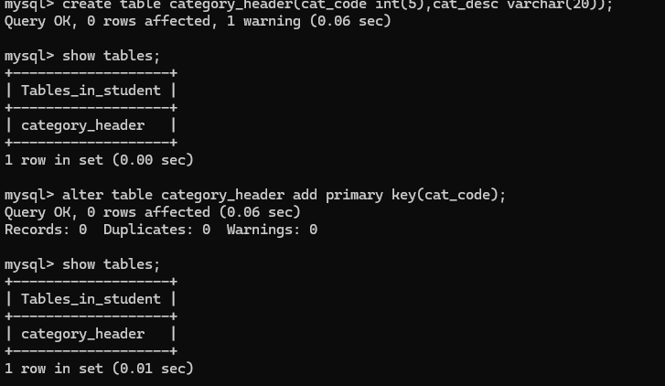
Q2
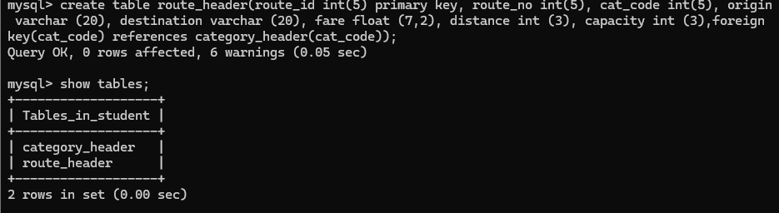

Q3

Q4

Q5
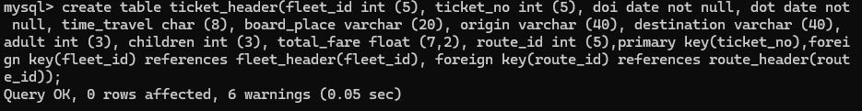

Q6

Q7
    - : Screenshots of the tables designed with constrains:
Q1
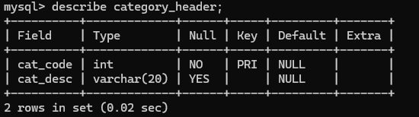
Q2
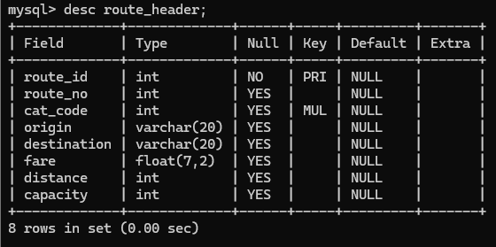
Q3
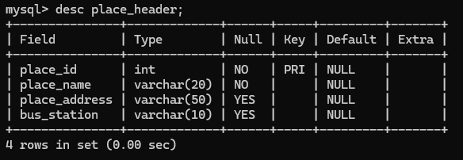
Q4
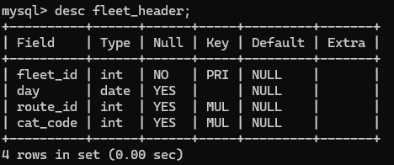
Q5
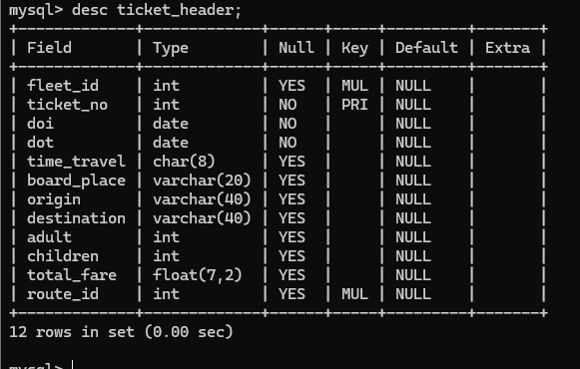
Q6
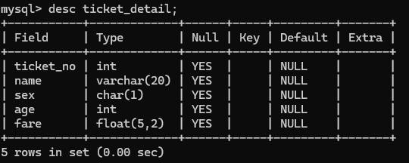
Q7
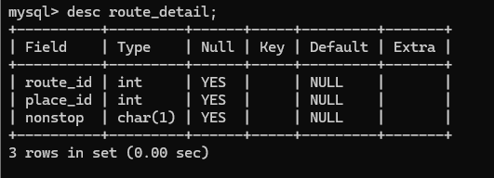
B.3 Observations and Learning:
(Students must write the observations and learning based on their understanding built about the subject matter and inferences drawn)

B.3 Conclusion:
(Students must write the observations and learning based on their understanding built about the subject matter and inferences drawn)

B.4 Question of Curiosity
(To be answered by student based on the practical performed and learning/observations)
- Comment the statement, “Primary key is no different than Foreign key”
- Differentiate between Business logic and constrains in Databases.
- Which other SQL DDL Commands can be applied on the tables generated?

ANS:

1.
​The statement that they are "no different" is a fundamental misunderstanding of relational theory. A Primary Key is a table's internal anchor; it uniquely identifies every record, ensuring no duplicates exist and no identity is "null." In contrast, a Foreign Key is an external bridge; its sole purpose is to point to a Primary Key in another table to create a relationship. While a table can have only one Primary Key to define itself, it can have multiple Foreign Keys to link to various other entities.

​2.
​The difference lies in enforcement versus calculation. Database Constraints are the "guardrails" of the data warehouse—rules like NOT NULL or UNIQUE that prevent structurally invalid data from ever being saved. Business Logic is the "brain" of the application, usually living in the code (like Python or Java). It handles nuanced, evolving rules—such as determining if a customer qualifies for a loyalty discount—that are too complex or prone to change to be hard-coded into the database schema.

​3.
​After a table is created, you primarily use the ALTER command to evolve its structure, such as adding new columns or changing data types. If the table is no longer needed, DROP deletes the entire structure and its data, while TRUNCATE acts as a fast reset by wiping all rows but leaving the table's "skeleton" intact. Additionally, RENAME can be used to update the nomenclature of tables or columns as the project requirements shift

